YOUR HUMANQ TEAMS TOOLKIT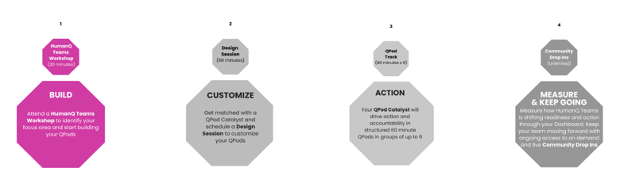
Complete this section BEFORE your Design Session with your QPod Catalyst

For help completing your Toolkit, please reference this 5 minute video HERE. Please note we are currently transitioning our product language, and the video language may not align to this Toolkit.

INSTRUCTIONS:
- List your top 2 pain points and top 2 opportunities below
- For each pain point and opportunity fill in each column with 5 (High), 3 (Medium) or 1 (Low)
- Add the total score for each pain point or opportunity in the last column
Operational Urgency: level of criticality to business
Employee Impact: number of employees impacted, ability to perform their role
Customer Impact: customer satisfaction, sales effectiveness, customer retention
Financial Impact: revenue growth, margins
Strategic Alignment: aligned to broader strategy
Pain Points and Opportunities | Operational Urgency | Customer Impact | Financial Impact | Employee Impact | Strategic Alignment | Total Score
 | Low = 1 Medium = 3 High = 5
Pain Point 1:  Engineers are not collaborating with product teams | 5 | 4 | 4 | 3 | 4 | 20
Pain Point 2:  R&D teams need to move faster and start innovating | 5 | 4 | 4 | 3 | 4 | 20
Opportunity 1:
[Insert here]
Opportunity 2:
[Insert here]

Your Full Name:

Your Title:

Company Name:

Total Number of Participants: (up to 24): Core Plan

Number of QPod Tracks Purchased: (up to 4): 2

Time Zone(s) of Participants: India, Israel, US

Your Focus Area | Pain Point or Opportunity: (from the previous page with the highest total score)

Key Business Metrics (what current business metrics are impacted by your focus area):

Employees Attending the HumanQ QPod Track(s):
- Department(s): (E.g. R&D, Sales, Engineering)
- Level(s): (E.g. Managers, Directors)
- Intact team? (Yes/No)
- Manager & Direct Reports Pairings: (E.g. QPod Track 1 will have a Manager with 2 of their Direct Reports)
Challenges: (what are the challenges your employees are facing and where are they stuck?)

Success: (what does success look like for you and your employees?)

How equipped have you been feeling to solve your focus area? (1 = not at all equipped -> 10 = fully equipped)

How equipped would you like to be to solve your focus area and achieve your desired business outcome(s)? (1 = not at all equipped -> 10 = fully equipped)

Anything else you would like to share with us on how HumanQ could get you there:

SELECTING YOUR QPOD TRACK:
- Based on your focus area, select the QPod Track that will best move your employees forward for the greatest impact
- During the Design Session with your QPod Catalyst, you will have an opportunity to customize each of the six QPods

OVERCOMING CHALLENGES & DRIVING IMPACT
QPOD 1: Defining the Pain Point
QPOD 2: What’s Holding You Back?
QPOD 3: Thinking Differently
QPOD 4: Asking Great Questions
QPOD 5: Transforming Problems into Solutions
QPOD 6: Working Smarter, Not Harder
QPOD TRACK 1

BUILDING FOR THE FUTURE
QPOD 1: Defining the Opportunity
QPOD 2: Starting with a Growth Mindset
QPOD 3: Think Big
QPOD 4: Act Bigger
QPOD 5: Balancing Strategy & Execution
QPOD 6: Measuring Success
QPOD TRACK 2

INNOVATING FOR GROWTH & AI
QPOD 1: Defining Innovation
QPOD 2: Taking Calculated Risks
QPOD 3: Where Are You Stuck?
QPOD 4: Growth Mindset in an Era of AI
QPOD 5: Resilience as a Muscle
QPOD 6: Measuring Progress
QPOD TRACK 4

UNLOCKING LEADERSHIP POTENTIAL
QPOD 1: Unlocking Your Leadership Potential
QPOD 2: Collaborating for Impact
QPOD 3: Building Trust in Teams
QPOD 4: Influencing Direction & Outcomes
QPOD 5: Taking 100% Ownership
QPOD 6: Your Success Blueprint
QPOD TRACK 3

QPod Track Selected & Designed:

Please note that the QPod Track name, including each of the six QPod names need to be clear and succinct for all platform and email purposes.

<INSERT QPOD TRACK NAME>
QPOD 1: Topic
QPOD 2: Topic
QPOD 3: Topic
QPOD 4: Topic
QPOD 5: Topic
QPOD 6: Topic

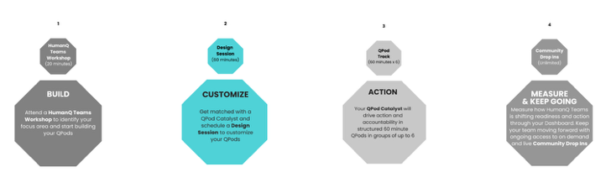
Complete this section DURING your Design Session with your QPod Catalyst
 | QPod Topic | 1 Key Challenge | 1 Key Question | Desired Outcome
QPod 1
QPod 2
QPod 3
QPod 4
QPod 5
QPod 6

QPOD TRACK DESCRIPTIONS

Defining Innovation: Develop a clear definition and understanding of what innovation mean to create alignment within the team
Taking Calculated Risks: Increase your comfort level with taking risks that will drive the business forward
Where are You Stuck?: Understand what’s blocking you from driving greater impact and create an action plan to overcome those blockers
Growth Mindset in an Era of AI: Learn to embrace technology and AI as a tool that can help increase your impact
Resilience as a Muscle: Develop greater resilience by learning to look at failure as an opportunity to learn from mistakes and do things better in the future
Measuring Progress: Identify the methods and metrics you will use to measure progress to ensure you are moving the in the direction
CT4: DRIVING INNOVATION & AI | INNOVATING FOR GROWTH
OVERCOMING CHALLENGES & DRIVING IMPACT
QPOD 1: Defining the Pain Point
Develop a clear definition and understanding of what the pain point is to create alignment within the team
QPOD 2: What’s Holding You Back?
Identify the blockers that are preventing you from reaching your full potential and that will help solve for the pain point
QPOD 3: Thinking Differently
Develop different ways of thinking about both challenges and opportunities to help identify new “outside the box” solutions
QPOD 4: Asking Great Questions
Uplevel communication, create alignment, and develop greater clarity by asking better questions
QPOD 5: Transforming Problems into Solutions
Change your mindset around how you look at roadblocks and learn to see them as opportunities to try things differently and achieve better outcomes
QPOD 6: Working Smarter, Not Harder
Develop the tools necessary to become more efficient in how you work to streamline processes to free up bandwidth for other things
QPOD TRACK 1
BUILDING FOR THE FUTURE
QPOD 1: Defining the Opportunity
Develop a clear definition and understanding of what the opportunity is to create alignment within the team
QPOD 2: Starting with a Growth Mindset
Learn to use more of a growth mindset rather than a fixed mindset to open possibilities and drive better business outcomes
QPOD 3: Think Big
Think beyond your role and your team to develop the big ideas that will drive business impact
QPOD 4: Act Bigger
Develop an action plan that will allow you to operationalize your big ideas to increase your level of impact
QPOD 5: Balancing Strategy & Execution
Understand the right balance between focusing on strategy and focusing on execution to ensure you’re thinking long-term, while acting short-term
QPOD 6: Measuring Success
Identify the methods and metrics you will use to measure success to ensure you are achieving your goals
QPOD TRACK 2
QPOD TRACK DESCRIPTIONS (CONT’D)

Defining Innovation: Develop a clear definition and understanding of what innovation mean to create alignment within the team
Taking Calculated Risks: Increase your comfort level with taking risks that will drive the business forward
Where are You Stuck?: Understand what’s blocking you from driving greater impact and create an action plan to overcome those blockers
Growth Mindset in an Era of AI: Learn to embrace technology and AI as a tool that can help increase your impact
Resilience as a Muscle: Develop greater resilience by learning to look at failure as an opportunity to learn from mistakes and do things better in the future
Measuring Progress: Identify the methods and metrics you will use to measure progress to ensure you are moving the in the direction
CT4: DRIVING INNOVATION & AI | INNOVATING FOR GROWTH
UNLOCKING LEADERSHIP POTENTIAL
QPOD 1: Unlocking Your Leadership Potential
Identify the mindset and behavioral changes you need to make to become a better leader
QPOD 2: Collaborating for Impact
Learn how to better collaborate with others across the organization to drive greater impact
QPOD 3: Building Trust in Teams
Develop an understanding of how to build trust with your teams to increase performance
QPOD 4: Influencing Direction & Outcomes
Understand how to influence different stakeholders to drive better outcomes
QPOD 5: Taking 100% Ownership
Develop an understand of what 100% ownership means and what you need to do differently to take full end-to-end ownership over your role and your impact
QPOD 6: Your Success Blueprint
Create a roadmap of what success looks like for you in the short and long term and how you’re going to achieve it
QPOD TRACK 3
INNOVATING FOR GROWTH & AI
QPOD 1: Defining Innovation
Develop a clear definition and understanding of what innovation means to create alignment within the team
QPOD 2: Taking Calculated Risks
Increase your assessment and comfort level with taking calculated risks to drive the business forward
QPOD 3: Where are You Stuck?
Understand where you are stuck and create an action plan to get unstuck and drive greater impact
QPOD 4: Growth Mindset in an Era of AI
Lean into opportunities to embrace technology and AI as a strategic tool that can help increase your impact
QPOD 5: Resilience as a Muscle
Develop greater resilience by learning to look at failure as an opportunity to learn from mistakes and do things better in the future
QPOD 6: Measuring Progress
Identify the methods and metrics you will use to measure progress to ensure you are moving in the right direction
QPOD TRACK 4

